***Managing S3 Lifecycle Policies***

Step 1-Selct a bucket for configuration

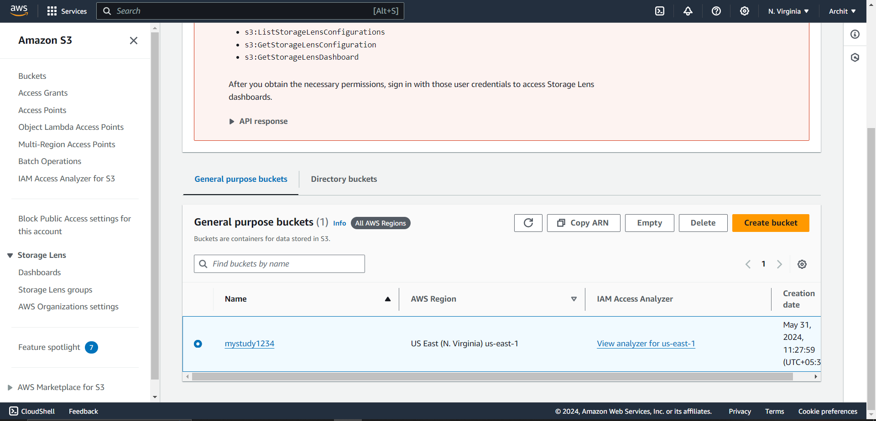

Step 2-Selct a bucket then go to management

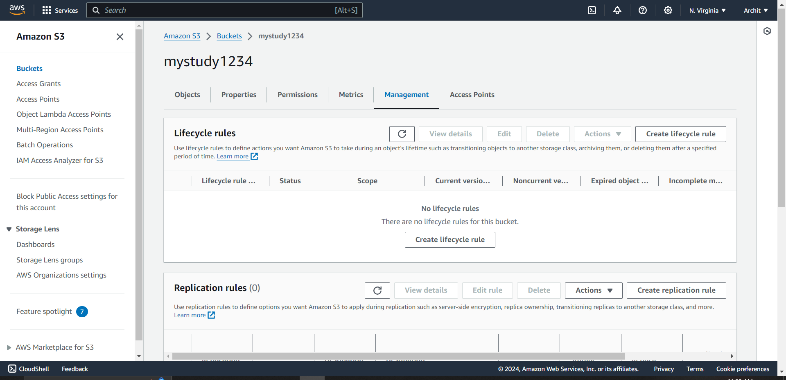

Step 3- Select Create Life Cycle Rule

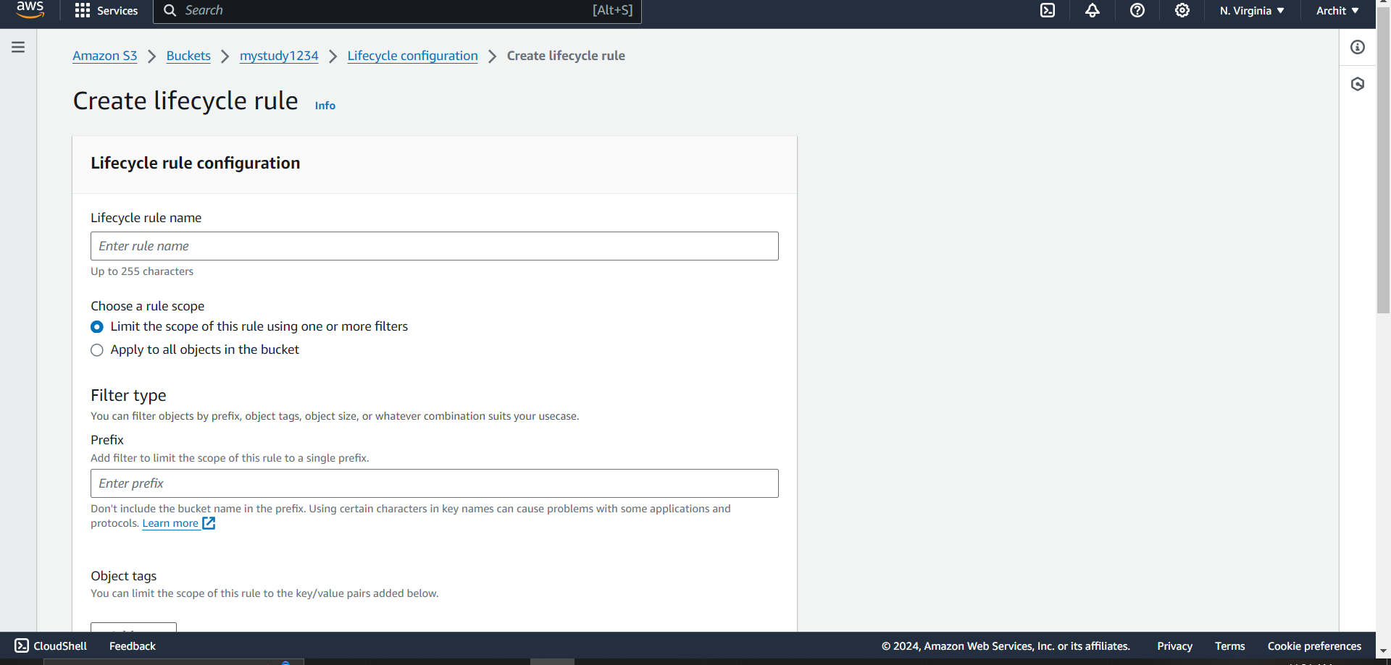

Step 4- Select rules accordingly

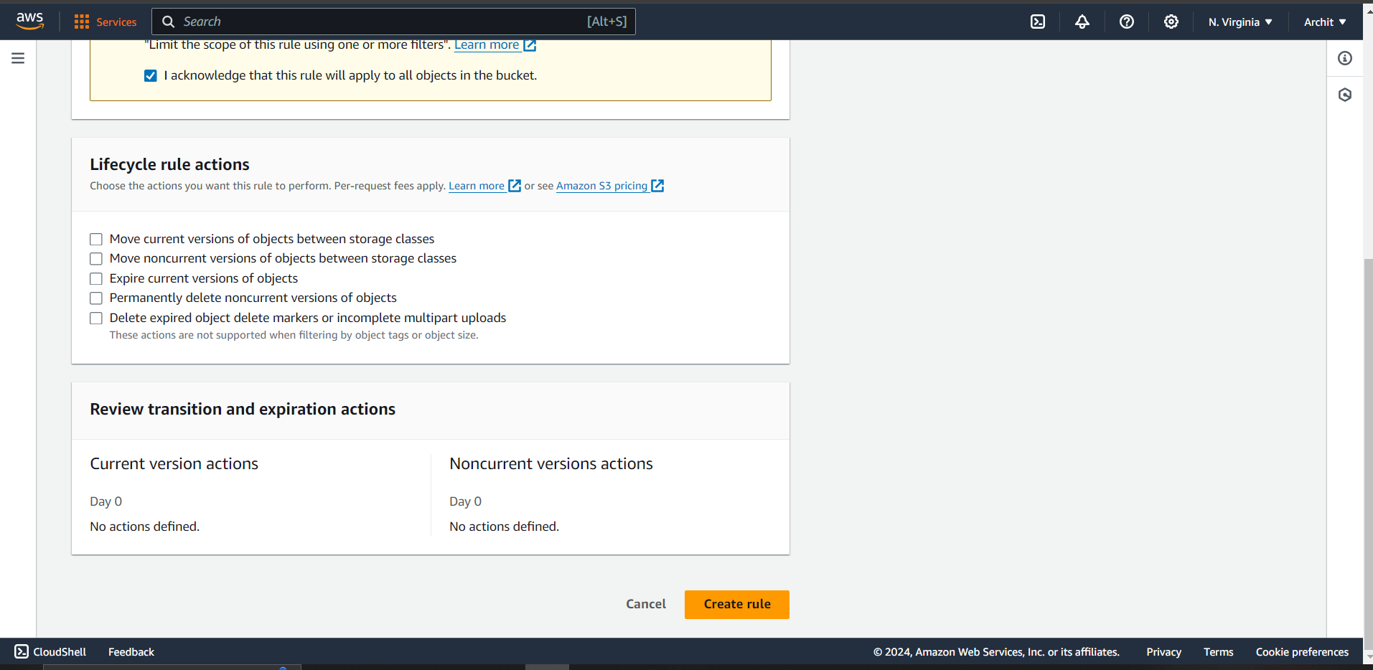

Step 5- click create

